Exercise 5: Triggers

BY: Shubham Sangram Bej

Aim
To create PL/SQL triggers that automatically perform actions whenever specific events occur in the database, ensuring data consistency, maintaining audit logs, and enforcing business rules.

Scenario 1: Automatically Update Last Modified Date

Problem Statement
Automatically update the last modified date when a customer's record is updated. Write a trigger UpdateCustomerLastModified that updates the LastModified column of the Customers table to the current date whenever a customer's record is updated.

Algorithm
- Create a BEFORE UPDATE trigger on the Customers table.
- Execute the trigger for each updated row.
- Assign the current system date to the LastModified column.
- Save the updated record.

Program

Creating Trigger:
CREATE OR REPLACE TRIGGER UPDATECUSTOMERLASTMODIFIED BEFORE
UPDATE ON CUSTOMERS
FOR EACH ROW
BEGIN
:NEW.LASTMODIFIED := SYSDATE;
END;
/

Testing:
UPDATE CUSTOMERS
SET
BALANCE = BALANCE + 500
WHERE
CUSTOMERID = 1;

COMMIT;

Verifying:
SELECT
CUSTOMERID,
NAME,
BALANCE,
LASTMODIFIED
FROM
CUSTOMERS
WHERE
CUSTOMERID = 1;

Output
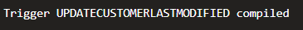

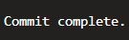

Scenario 2: Maintain Transaction Audit Log

Problem Statement
Maintain an audit log for all transactions. Write a trigger LogTransaction that inserts a record into an AuditLog table whenever a transaction is inserted into the Transactions table.

Algorithm
- Create the AuditLog table.
- Create a sequence to generate unique Audit IDs.
- Create an AFTER INSERT trigger on the Transactions table.
- Insert transaction details into the AuditLog table whenever a new transaction is added.

Program

Creating Audit Table:
CREATE TABLE AUDITLOG (
AUDITID NUMBER PRIMARY KEY,
TRANSACTIONID NUMBER,
ACTIONTYPE VARCHAR2(30),
ACTIONDATE DATE
);

Creating a Sequence:
CREATE SEQUENCE AUDITSEQUENCE START WITH 1 INCREMENT BY 1;

Creating Trigger:
CREATE OR REPLACE TRIGGER LOGTRANSACTION AFTER
INSERT ON TRANSACTIONS
FOR EACH ROW
BEGIN
INSERT INTO AUDITLOG VALUES ( AUDITSEQUENCE.NEXTVAL,
:NEW.TRANSACTIONID,
'NEW TRANSACTION',
SYSDATE );

END;
/

Testing (Inserting a Transaction):
INSERT INTO TRANSACTIONS VALUES ( 20,
1,
SYSDATE,
500,
'Deposit' );

COMMIT;

Verifying:
SELECT
*
FROM
AUDITLOG;

Output
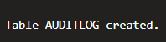

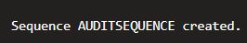

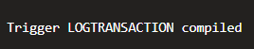
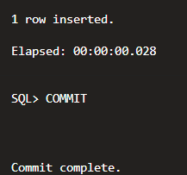

Scenario 3: Enforce Transaction Rules

Problem Statement
Enforce business rules on deposits and withdrawals. Write a trigger CheckTransactionRules that ensures withdrawals do not exceed the balance and deposits are positive before inserting a record into the Transactions table.

Algorithm
- Create a BEFORE INSERT trigger on the Transactions table.
- For withdrawal transactions, retrieve the account balance.
- Prevent withdrawals exceeding the available balance.
- For deposit transactions, ensure the deposit amount is greater than zero.
- Display an appropriate error message if validation fails.

Program

Creating Trigger:
CREATE OR REPLACE TRIGGER CHECKTRANSACTIONRULES BEFORE
INSERT ON TRANSACTIONS
FOR EACH ROW
DECLARE
V_BALANCE NUMBER;
BEGIN
IF UPPER(:NEW.TRANSACTIONTYPE) = 'WITHDRAWAL' THEN
SELECT
BALANCE
INTO V_BALANCE
FROM
ACCOUNTS
WHERE
ACCOUNTID = :NEW.ACCOUNTID;

IF :NEW.AMOUNT > V_BALANCE THEN
RAISE_APPLICATION_ERROR(-20001, 'Withdrawal amount exceeds account balance.');
END IF;

ELSIF UPPER(:NEW.TRANSACTIONTYPE) = 'DEPOSIT' THEN
IF :NEW.AMOUNT <= 0 THEN
RAISE_APPLICATION_ERROR(-20002, 'Deposit amount should be greater than zero.');
END IF;
END IF;
END;
/

Test-1 (Deposit):
INSERT INTO TRANSACTIONS VALUES ( 21,
1,
SYSDATE,
1000,
'Deposit' );

COMMIT;

Test-2 (Invalid Deposit):
INSERT INTO TRANSACTIONS VALUES ( 22,
1,
SYSDATE,
- 500,
'Deposit' );

Test-3 (Withdrawal):
INSERT INTO TRANSACTIONS VALUES ( 23,
1,
SYSDATE,
50000,
'Withdrawal' );

Output
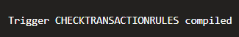

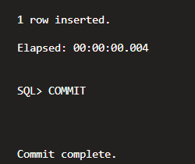

Conclusion
This exercise demonstrated the implementation of PL/SQL triggers to automate database operations. Triggers were used to update modification timestamps automatically, maintain transaction audit records, and enforce banking business rules before transactions are inserted. These mechanisms improve data integrity, security, and automation within the database system.

